

**Comp6234 – Coursework: Creating a Data Story-Outline**

Junming Zhang 29299527 [jz1g17@ecs.soton.ac.uk](mailto:jz1g17@ecs.soton.ac.uk)

## 1. Briefly description of data story

ECS students may interesting in the technology, computer-related job. Thus, the story will tell people the distribution of job positions and the salary of different technology jobs. Moreover, which skills support more opportunities to apply related job will be listed.

Two datasets which crawled from job search websites Monster.com and Dice.com support lots of relevant information, job positions, location, salary and skill required. Valid data can be observed after process the original dataset. Other three datasets are related to address and population distribution in the USA. Then the job positions and geographic information can be researched together to provide a job distribution map to help people find a better place for specific jobs.

## 2. Datasets acquired

1. job lists from Dice.com
2. job lists from Monster.com
3. USA population of each city
4. USA addresses and corresponding zip codes.
5. USA population and their age distribution based on zip codes.

## 3. Tools

1. R or Python to clean data.
2. Tableau.
3. D3.
4. GeoJSON: work with D3 to plot map based chart.
5. Word Clouds: generate high-frequency words of required job skills.

## 4. Charts

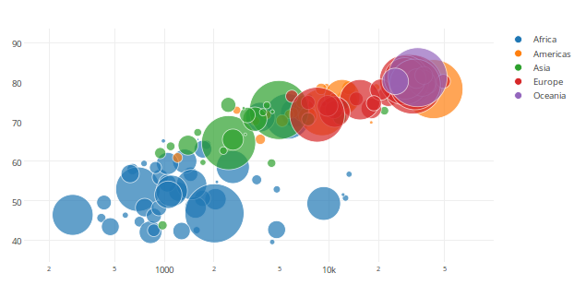

***Figure 1. Bubble chart***

Bubble chart can be used to illustrate the salary of different technology job and their frequency.

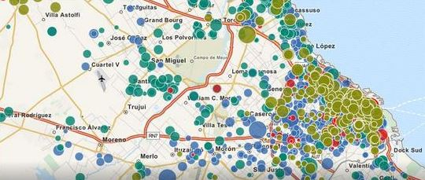

***Figure 2. Map chart***

Map chart will tell people the distribution of different job, thus user could find a better place for the specific job.

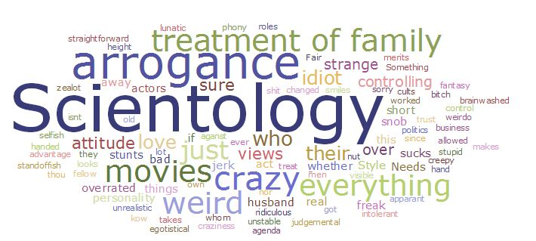

***Figure 3. High-frequency chart***

The high-frequency chart will be used to display the useful skill to find a job, thus people could know which skill is better to control when they finding a job.